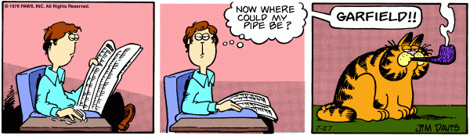

The story here is of a plain man, but he is more than that, but first let us say that he's Jon, a plain man. And then there is a cat. Garfield. When I was 18, I saw this comic, and I said "Okay. let me look at this here. What is this doing to me? Why is this so powerful?" Jon Arbuckle sits here, comfortable in his home, and reads his newspaper, then taps his fingers on an end table and feels for something. What is it? It is something he needs, but it is not there. And then he looks up, slightly cockeyed. His newspaper's in his lap now, and he thinks this. Now where could my pipe be? This. I always come to this, because I was a young man. I'm older now, and I still don't have the secrets, the answers, so this question still rings true. It's almost like divine intervention, suddenly it is there, and it overpowers you. A cat is smoking a pipe. It is the man's pipe, it's Jon's pipe, but the cat. this cat, Garfield, is smoking the pipe. And from afar, and someplace near, but not clear. near but not clear. The man calls out. Jon calls out, he is shocked. "Garfield!" he shouts. The cat's name.

But, let's take a step back. And when I first came across this comic strip, I was at my father's house. So I thought, "Ah, interesting. I'll have to see this later." I snipped out the little comic, and held on to it. And five days later, I reexamined it. And it gripped me, I needed to find out more about this. The information I had was minimal, but enough. An orange cat, that seemed to be the lynchpin of this whole operation. A signature in the bottom right corner, a man's name. Jim Davis. When I see the pipe strip I see perfection. How could a mere mortal even MAKE this? You have to wonder about the man who is able to even, just once, create the perfect form, a literally flawless execution of art, brilliance! They very well may say the same things about Jim Davis in five hundred years that we say about the great philosophical and artistic masters from centuries ago.

I often look at Garfield's particular pose, in this strip. He is poised, and statuesque. And his cat stare is reminiscent of the fiery gazes often found in religious iconography. But still, his eyes are playful, lying somewhere between the solemn father's expression in Rembrandt's "Return of the Prodigal Son," and the coy smirk of Da Vinci's "Saint John The Baptist" I have cried. I've cried, I've cried. I've cried over this piece. It just gets in my soul. I can't help but read the thought bubble, over and over again. Now where could my pipe be? It is a profound question. Why am I here? What is my purpose? It is reflection and self-examination here. It is facing the dust, the misery of a cold, careless universe.

You can feel the weight of it. The thoughtful, controlled outlines mixed with the occasional, chaotic scribbles at work in the shadows and Garfield's dark stripes. He is the embodiment of chaos, disorder, death, destruction, desolation! This is why Jim Davis has chosen smoking. It represents recklessness, disregard for life. Garfield defies life; he sits defiant, saying nothing, but looking as if he could say, "Then let me die, it does not matter." Garfield, the thief-cat, evil and malicious is placed to the right.

And note, the two forms of Jon; the Jon on the left, still innocent, still draped in the. delight, of the lack of knowledge. He is. the humans in the Garden of Eden. He feels for his pipe. But he has yet to eat from the tree, and Garfield, the sinister serpent. Notice how Jim Davis has framed this. The center Jon is locked in a struggle, between his innocence, and his knowledge of the truth. And Jim Davis floats over all this, as creator, a God, of sorts, in his own right. And he presents this cautionary message to us all; it is as if he is speaking from high and he is saying, unto our awaiting ears. Where will you be, when the cat reveals himself? Be like Jon Arbuckle, as he lowers his head. Bow with Jon Arbuckle, and praise unto the creator, Jim Davis.